Ref. No.: MES IMCC/ 358 /2024-25 Date: 19/ 04/ 2025

**CERTIFICATE**

This is to certify that the Project entitled **“BillCraftr - Invoice Generator”** is completed by **Krish Undre** of M.C.A. Semester II for the Academic Year 2024-25 at MES’ Institute of Management & Career Courses (IMCC), Pune - 411038.

To the best of our knowledge, this is an original study done by the said student, and important sources used by him/her have been duly acknowledged in this report.

The report is submitted as part of the course ITP21 Mini Project for the Academic Year 2024-25, as per the rules and guidelines prescribed by the institute.

  

**Ms. Kalpana Dhende Ms. Manasi Shirurkar Dr. Ravikant Zirmite**

Project Coordinator Program Coordinator Head, Dept. Of MCA

Ref. No.: MES IMCC/ 358 /2024-25 Date: 19/ 04/ 2025

**CERTIFICATE**

This is to certify that the Project entitled **“BillCraftr - Invoice Generator”** is completed by **Vaibhavi Kulkarni** of M.C.A. Semester II for the Academic Year 2024-25 at MES’ Institute of Management & Career Courses (IMCC), Pune - 411038.

To the best of our knowledge, this is an original study done by the said student, and important sources used by him/her have been duly acknowledged in this report.

The report is submitted as part of the course ITP21 Mini Project for the Academic Year 2024-25, as per the rules and guidelines prescribed by the institute.

  

**Ms. Kalpana Dhende Ms. Manasi Shirurkar Dr. Ravikant Zirmite**

Project Coordinator Program Coordinator Head, Dept. Of MCA

**Project Title: BillCrafter - Invoice Generator**

**Group no. : 38**

**Technologies used:**

* ReactJs
* Firebase
* Bootstrap
* Third Party apps like - EmailJS, ReactHotToast, DiceBear

**Product Functions/Modules**

**1. User Authentication & Authorization**

* **Sign-Up/Login/Logout**: Allows users to create accounts, log in, and manage their sessions.
* **Password Management:** Includes features for password recovery, reset, and change.
* **User Roles:** Differentiates between regular users and admins.

**2. Invoice Templates**

* **Template Gallery**: A collection of pre-designed templates for users to choose from.
* **Template Customization**: Allows users to customize the templates by entering their information and adjusting elements like colors, logos, fonts, etc.
* **Preview Option**: Provides users a live preview of their invoice before downloading.

**3. Data Input & Processing**

* **User Input Form**: Allows users to input their invoice details (e.g., client name, address, item description, pricing, etc.).
* **Dynamic Data Binding**: Maps user input to the chosen template dynamically, updating in real time as users make changes.
* **Validation**: Ensures the entered data (like price, dates, and other values) is correct and complete before generating the invoice.

**4. Custom Pricing & Personalization**

* **Discount & Tax Calculators**: Automatically apply discounts, taxes, or other fees based on user input.
* **Personalization Features:** Allows users to add personal branding elements such as logos, signatures, and personalized notes.

**5. History & Activity Tracking**

* **Activity History**: Stores the user's past invoices and activities (generated documents, templates used, data input, etc.).
* **Invoice Management**: Users can view, edit, and delete previously generated invoices from their history.
* **Export & Download**: Allows users to download or export past invoices in different formats (e.g., PDF, Excel,GoogleDocs).

**6. Admin Dashboard**

* **User Management**: Admins can manage user accounts, including activity reports, data management, etc.
* **Template Management**: Admins can add, remove, or modify available templates and pricing options.
* **System Analytics:** Track user activity, popular templates, or document types, and usage trends.

**7. Email & Notification System**

* **Invoice Emailing**: Automatically send the generated invoice to users or their clients via email.
* **Notifications**: Alert users when a new invoice is generated, when updates are made, or when an invoice is viewed/downloaded.

**8. UI/UX & Responsiveness**

* **Responsive Design**: Ensure the platform is usable on both desktop and mobile devices.
* **Intuitive Interface:** A user-friendly interface for ease of navigation and smooth workflow from template selection to invoice generation.

**9. Cloud Storage & File Management**

* **Cloud-Based Storage**: Securely store generated invoices on the cloud, providing users access from anywhere.
* **File Naming & Versioning:** Automatically organize files by user, date, and other relevant identifiers. Versioning helps in tracking document changes over time.

**Users of system :**

1. Admins
2. Individual Users
3. Business Groups

**Index**

| **Sr No.** | **Content** |
| --- | --- |
| 1 | Introduction of Project |
| 2 | Problem Statement and Objective |
| 3 | Scope & Functionalities of Project |
| 4 | Use Case, Class and ER Diagram |
| 5 | Input Design, Output Design (GUI) |
| 6 | Database Design |
| 7 | Validations |
| 8 | Conclusion |

## Introduction

BillCraftr is a modern, intuitive web-based invoice generator designed to simplify billing for freelancers, entrepreneurs, and small business owners. The platform enables users to create, customize, and download professional invoices with ease, using multiple ready-made templates.

Built with user experience in mind, BillCraftr streamlines the invoicing process, removing the complexity and time constraints of traditional invoice creation tools. Whether you're billing a client or organizing business records, BillCraftr ensures you do it quickly, beautifully, and efficiently.

### Key Highlights:

#### Instant Invoice Generation

Users can create invoices in just a few clicks by entering essential details such as client information, services/products, pricing, and payment terms. The platform takes care of formatting and styling, giving you a polished, ready-to-send invoice without the hassle of manual design.

#### Multiple Professional Templates

BillCraftr offers a variety of customizable templates that suit different business needs and aesthetics. Whether you prefer a sleek modern look, a more formal corporate design, or a minimalist style, there’s a template for you. These templates are consistently updated and optimized for clarity, branding, and professional presentation.

#### Download in Multiple Formats

Invoices can be downloaded in multiple formats such as PDF, DOC, and HTML. This flexibility ensures compatibility across platforms and meets different user needs—whether it's for sending via email, uploading to accounting software, or keeping internal records.

#### User Accounts & History Tracking

Upon logging in, users can view their entire invoice history, making it easier to keep track of previous transactions. This feature not only improves user experience but also helps users stay organized with built-in record-keeping.

#### Responsive & Intuitive Design

The platform is built with a mobile-first and responsive design approach, ensuring seamless use across devices—be it a phone, tablet, or desktop. Every interaction is smooth and supported with subtle animations using Framer Motion for enhanced engagement.

#### Secure & Private

User data is handled securely with Firebase Authentication and best practices in session handling. Whether logging in via email or Google, your information stays protected.

#### Call-to-Action Focused UI

Using a clean and modern color palette, the interface places focus on high-impact areas like “Generate Invoice” and “Download,” guiding users through a clear, goal-oriented experience.

## Problem Statement

In today's fast-paced digital economy, small businesses, freelancers, and individual professionals often struggle with generating professional, consistent, and legally compliant invoices. Traditional tools like spreadsheets or manual templates are time-consuming, error-prone, and lack the polish expected by clients. Additionally, many existing online solutions are either too complex, require subscriptions, or do not offer customization options to cater to individual branding needs. Users need a solution that is simple, efficient, aesthetically appealing, and flexible enough to accommodate various invoice styles.

## Objective of the Project

The primary objective of **BillCraftr** is to provide an intuitive, user-friendly platform that allows users to effortlessly create, customize, and download professional invoices. The project aims to:

1. **Simplify the invoice creation process** with easy-to-use input forms and pre-designed templates.
2. **Offer multiple download options** (PDF, DOC, HTML) for flexibility and compatibility.
3. **Provide template variety and customization** to suit diverse business styles and branding preferences.
4. **Enable user account functionality** so users can save, view, and manage their invoicing history.
5. **Introduce a custom pricing model** for businesses that require personalized invoice layouts or other business documentation.
6. **Maintain a responsive, accessible, and visually appealing interface**, ensuring a seamless experience across all devices.
7. **Ensure secure authentication and data handling**, protecting user information with industry-standard practices.

## Scope of the Project

**BillCraftr** is a web-based invoice generation platform tailored for freelancers, entrepreneurs, and small to medium-sized businesses. The scope includes building a scalable and visually engaging application that facilitates:

* Creation and management of professional invoices
* Customization and download of invoice templates
* User authentication and a secure login system
* History tracking for previously generated invoices
* A custom pricing mechanism for premium personalized templates and documents

The platform is designed to remain intuitive while offering flexibility for advanced users, ensuring it serves both individual users and growing businesses with diverse invoicing needs.

## Functionalities of the Project

### User Authentication

* Sign up / Log in using email & password or Google authentication
* Secure session management
* Access to personal invoice history upon login

### Invoice Generator

* Dynamic form for entering invoice details: company info, client info, item list, taxes, terms, etc.
* Real-time preview of invoice as the data is entered
* Auto-calculation of totals and taxes

### Template Selection

* Multiple professionally-designed templates
* Option to switch between templates before download
* Responsive design to ensure consistent layout across devices

### Download & Export

* Download invoices in various formats: PDF, DOC, and HTML
* Support for print-friendly versions

### Custom Pricing & Personalization

* Users can opt for premium customization (e.g., logo placement, color scheme, layout changes)
* Request submission for additional document types like estimates, receipts, or quotes

### History & Activity Log

* Logged-in users can access previously generated invoices
* View, re-download, or delete past invoices

### Contact & Support

* Contact form integrated with EmailJS or backend service
* FAQ section and testimonials for social proof and guidance

### UI/UX Enhancements

* Smooth animations using Framer Motion
* Responsive, mobile-friendly layout
* Accessible design with contrast and color palette optimized for readability

**Entity-Relationship Diagram (ERD)**

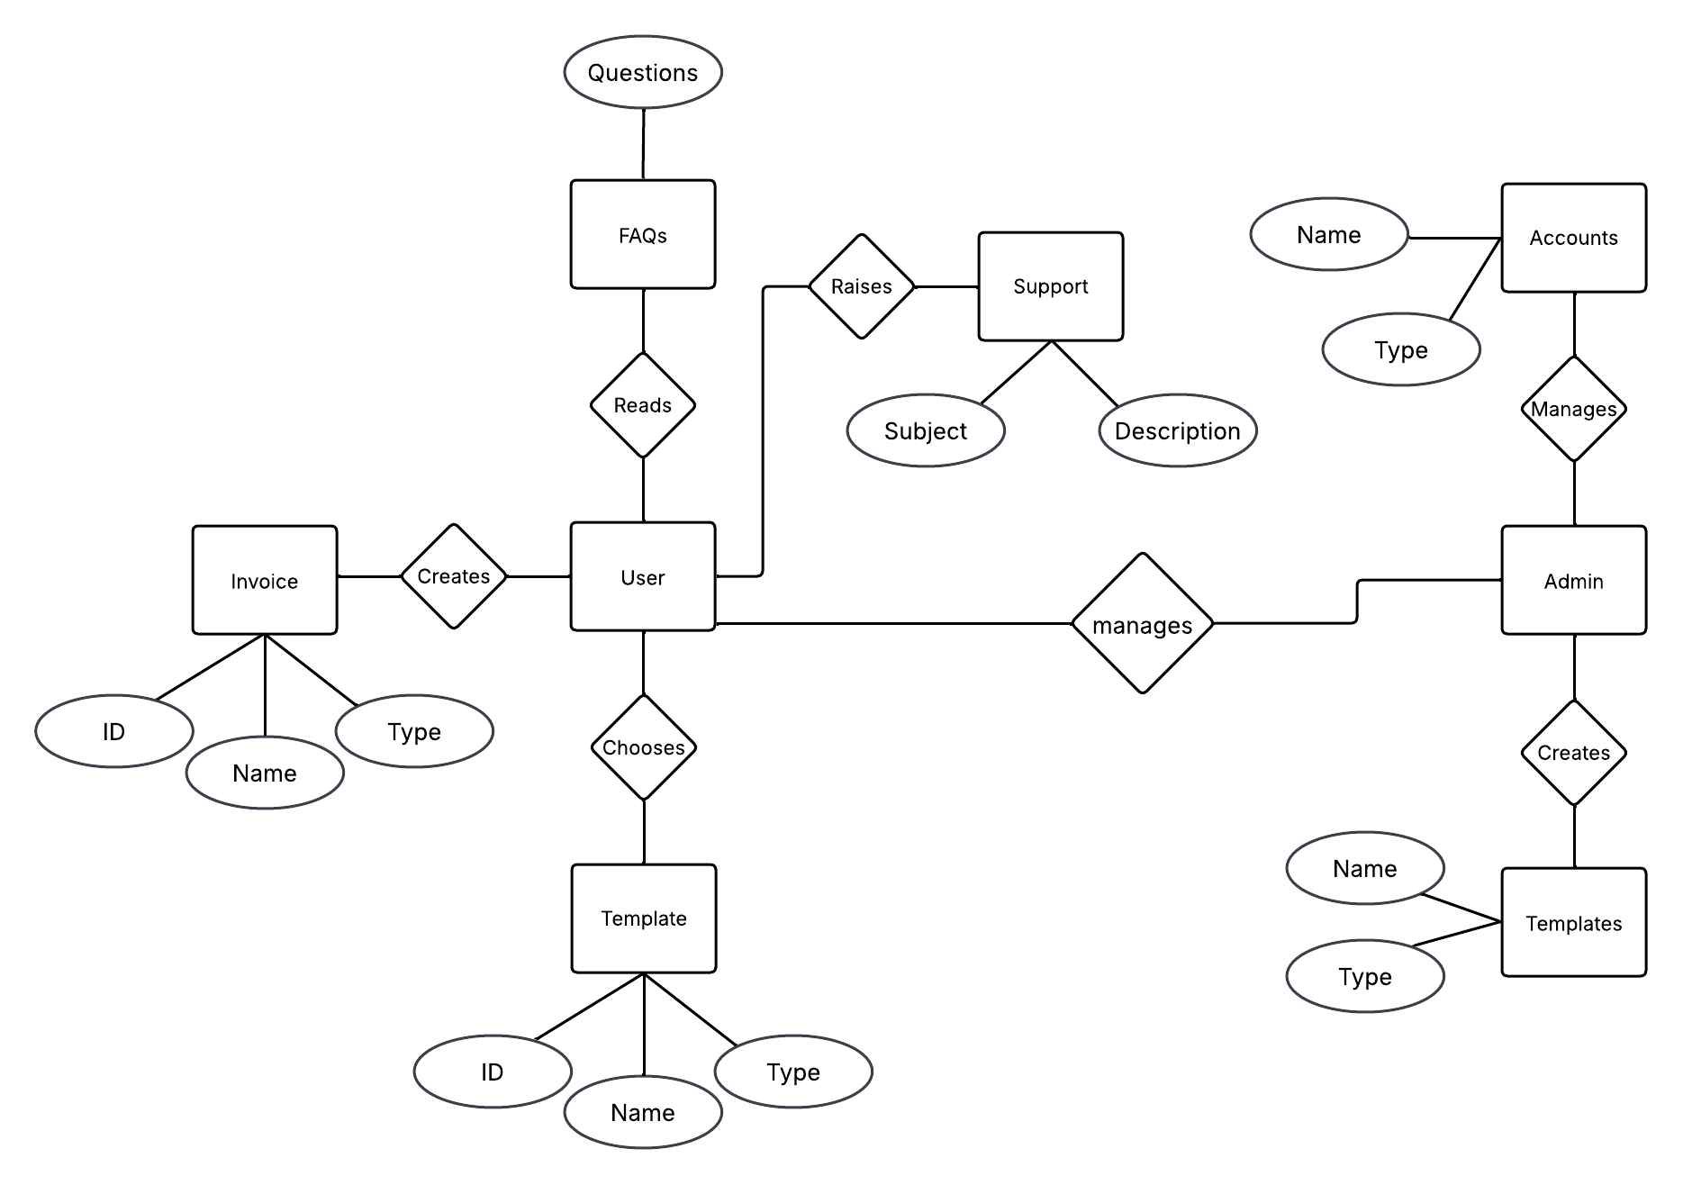

**Class Diagram**

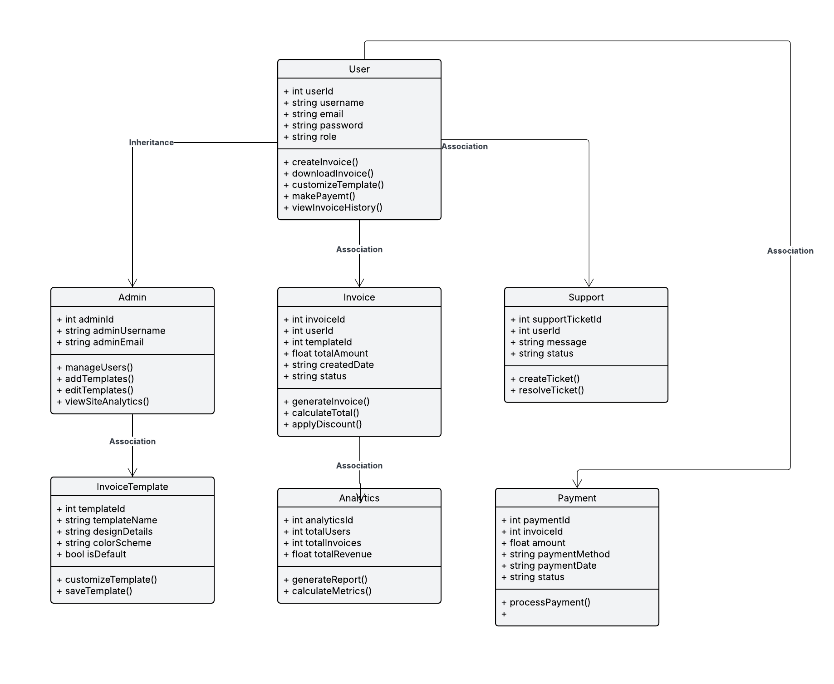

**UML Use Case Diagram**

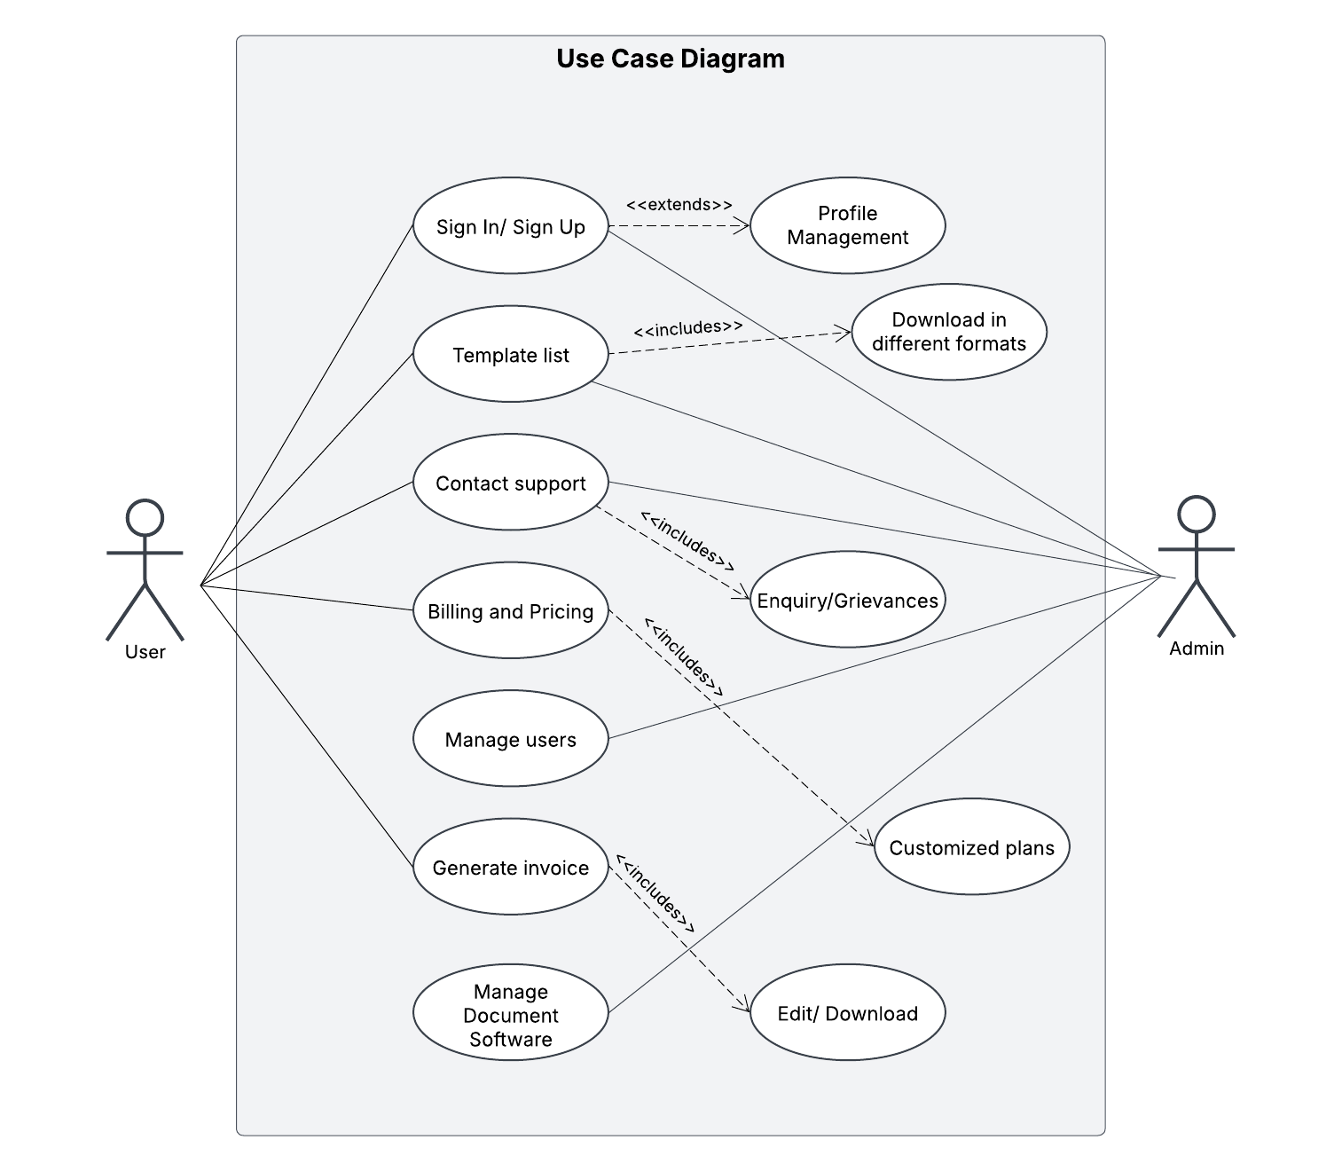

**Input Design, Output Design (GUI)**

**Homepage**

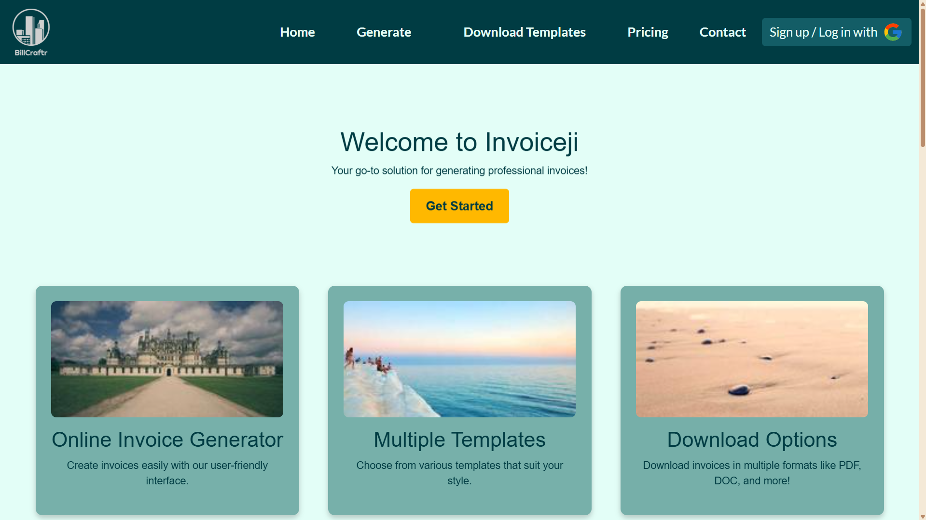

**Sign In Pop-up**

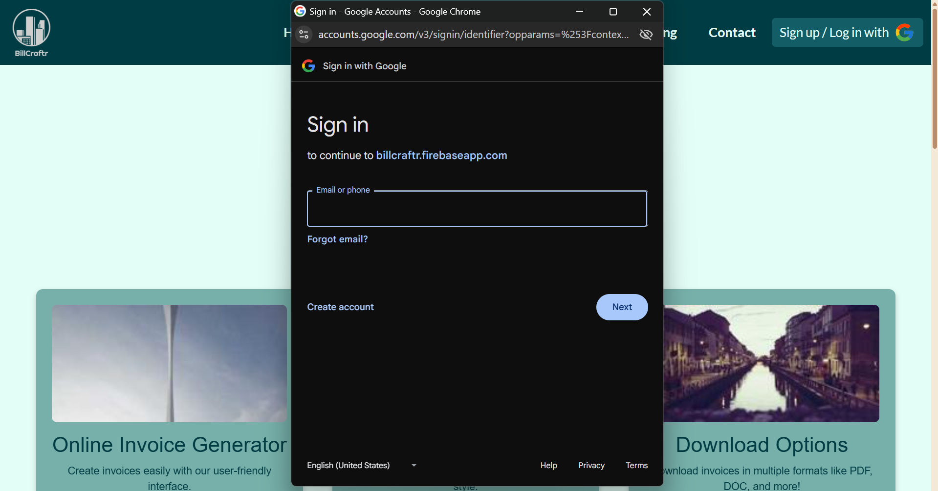

**Contact Page**

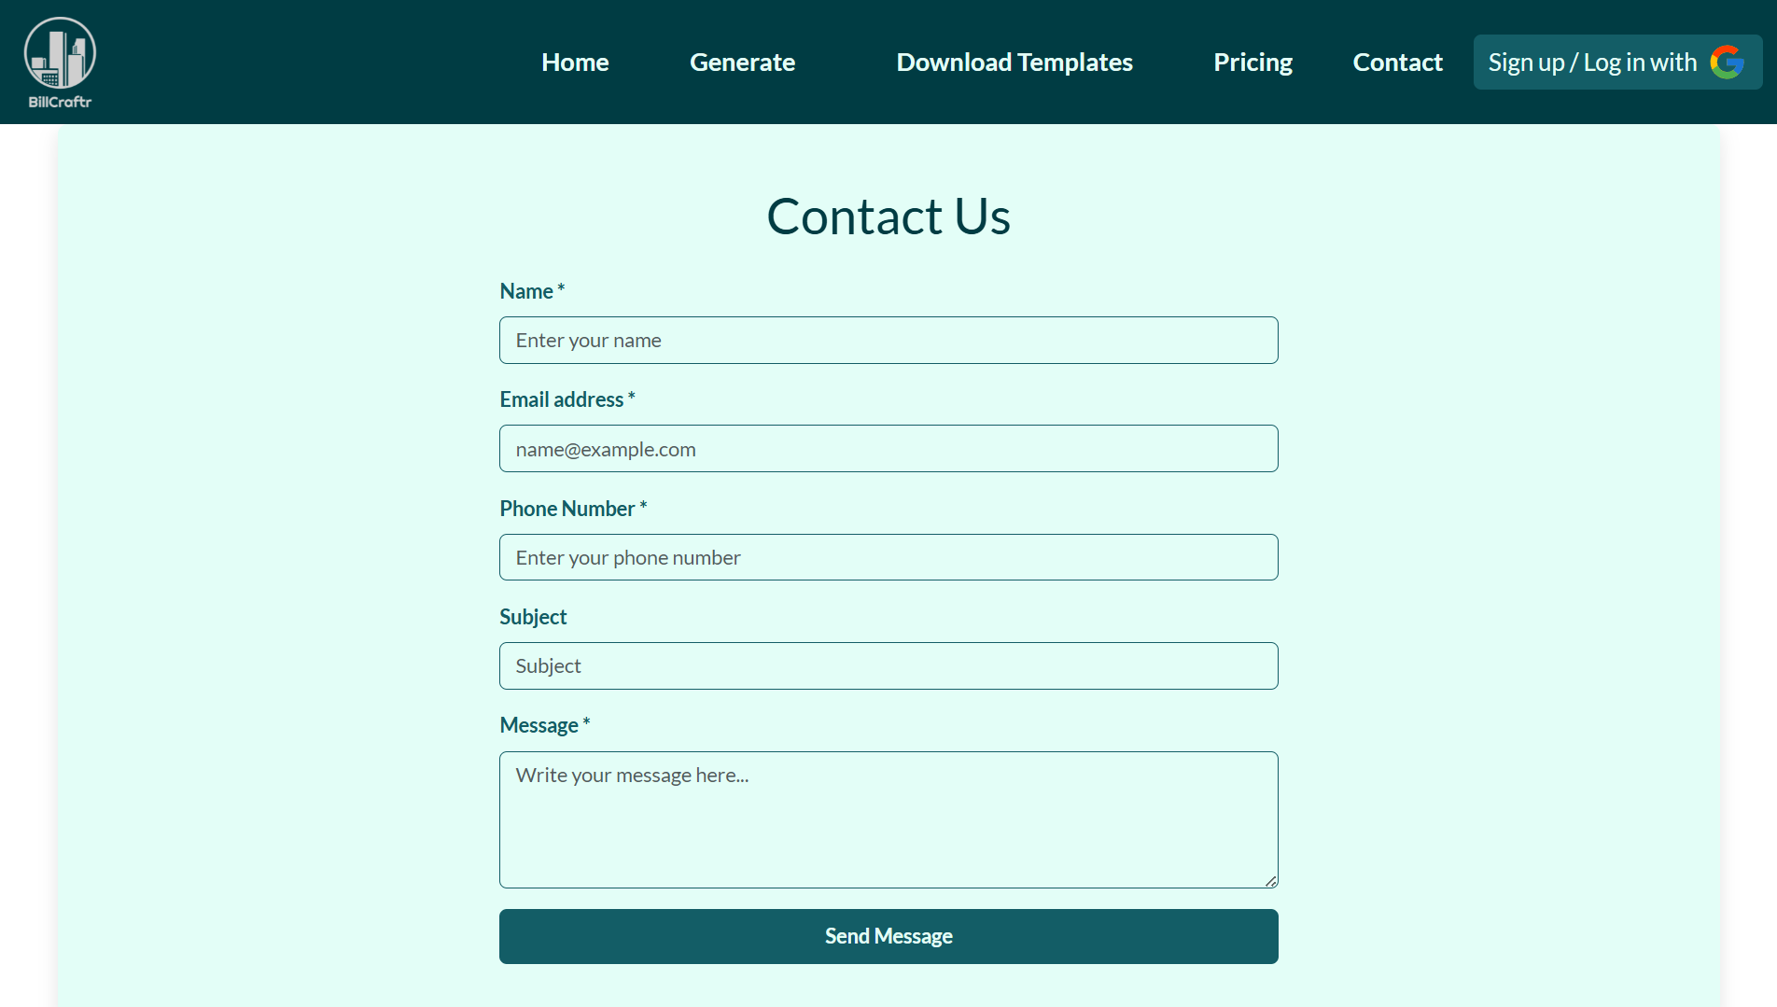

**Profile Page**

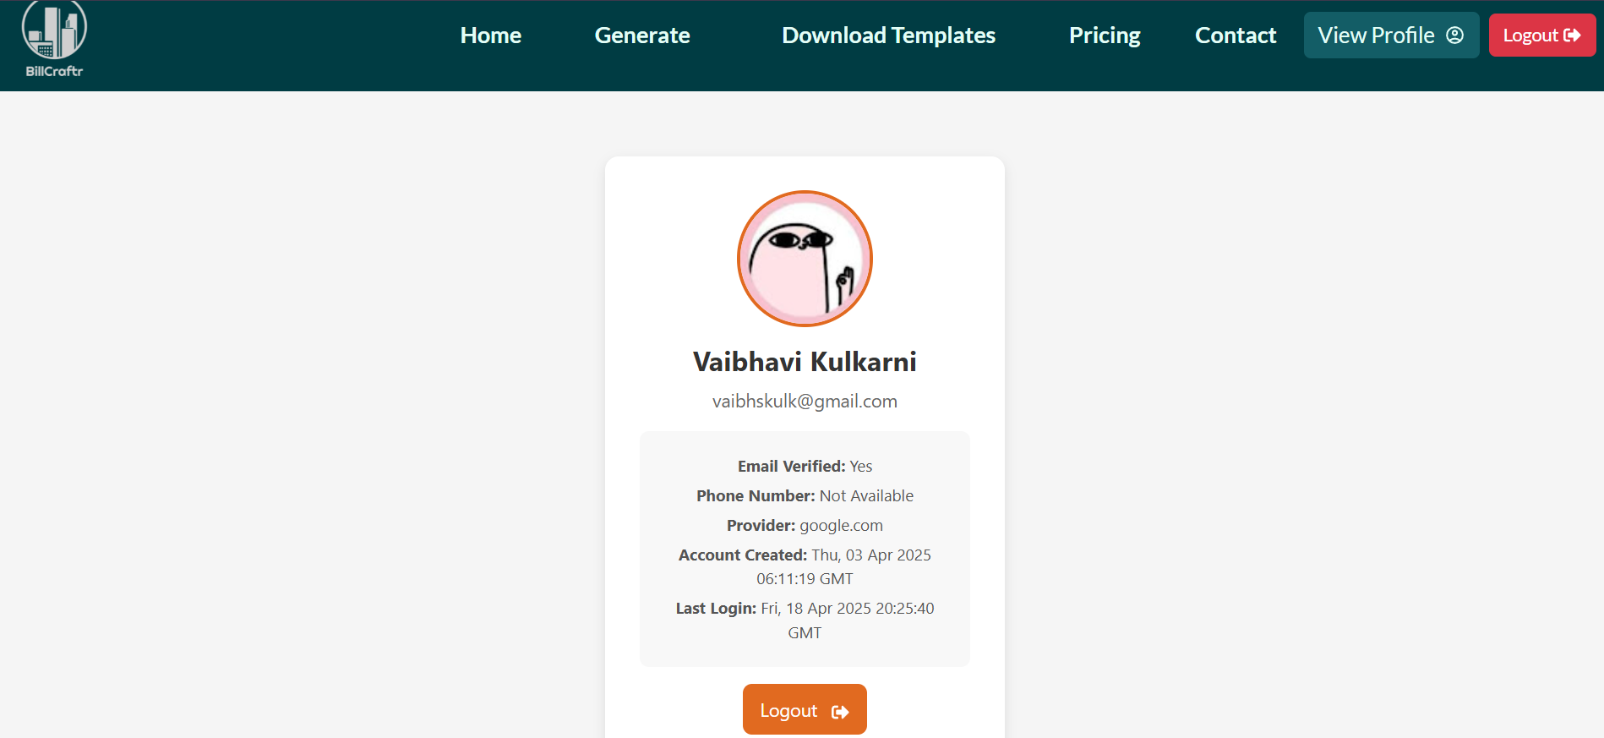

**Error Page**

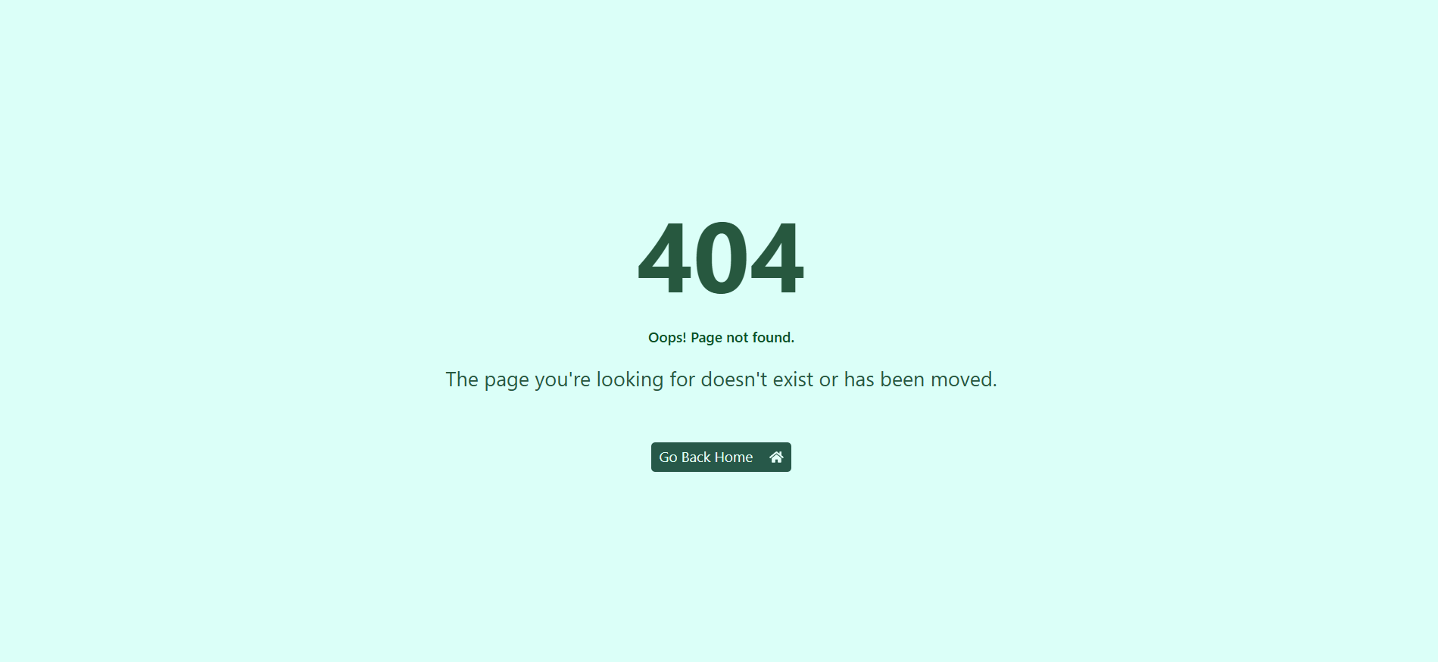

**Generate Invoice Page along with Footer**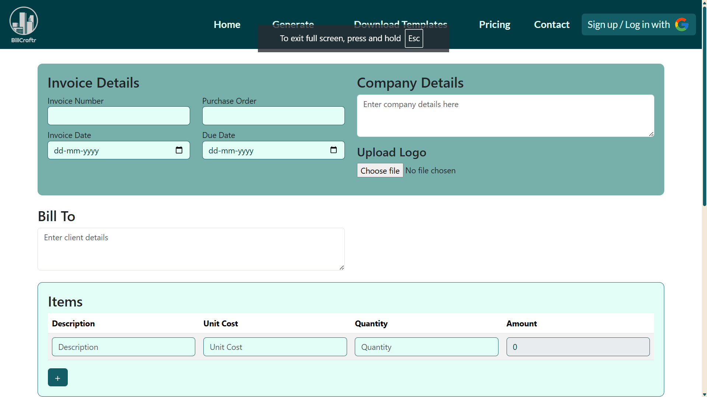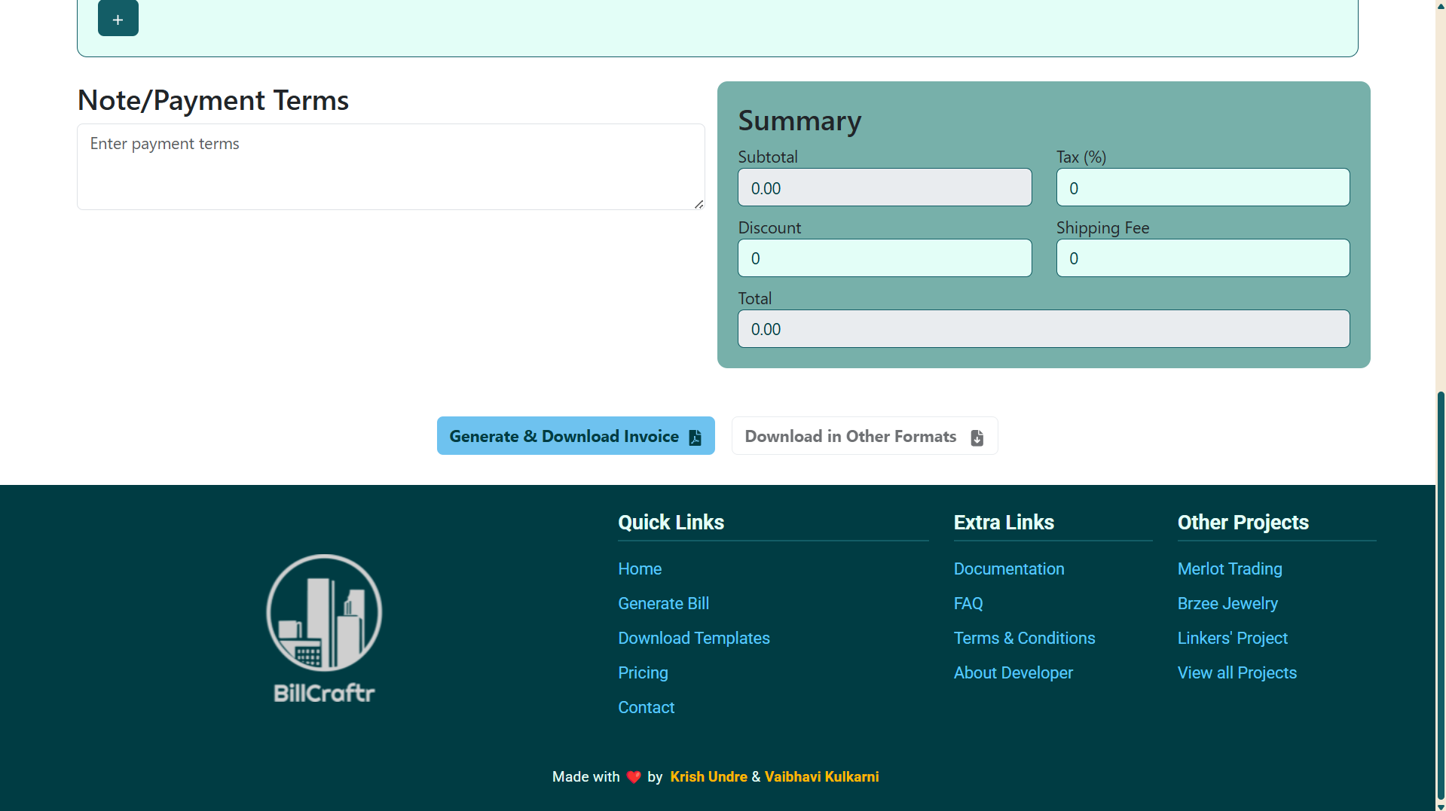

**Conclusion**

**BillCraftr** successfully delivers a comprehensive, accessible, and efficient invoicing solution tailored for freelancers, startups, and growing businesses. With its modern design and feature-rich capabilities, the platform removes the complexity from invoice creation and transforms it into a smooth, professional experience.

At its heart, **BillCraftr** is built to be intuitive. Users can generate fully formatted invoices simply by entering their data into well-structured forms without the need to design or format documents manually. Every step is optimized for speed, simplicity, and professionalism, from selecting beautiful pre-built templates to downloading invoices in multiple formats (PDF, DOC, HTML).

The platform is fully **responsive**, ensuring a seamless experience across devices, whether it's a desktop, tablet, or mobile. Key workflows are animated using **Framer Motion**, giving the interface a sleek and modern feel without compromising performance.

### Integration with Third-Party Tools

BillCraftr leverages powerful third-party integrations to enhance functionality and user experience:

* **EmailJS**: Enables direct communication between users and the support team through a contact form without needing a backend. It helps users report issues, request premium services, or share feedback in real-time, making support **accessible and efficient**.
* **DiceBear Avatars**: Used for dynamically generating unique user profile icons based on user input (e.g., email or username). This adds a personal touch, especially in the user's dashboard or invoice history, without requiring image uploads.
* **React Hot Toast**: Implements sleek and non-intrusive notifications across the platform—for example, when an invoice is successfully generated, an error occurs, or a user logs in/out. These real-time toasts improve the UX by offering **instant feedback** and **maintaining flow**.

### User-Centric Design

With secure **authentication mechanisms** including email/password and Google Sign-In, each user’s data and invoice history remain private and accessible only to them. Once logged in, users can easily revisit their invoice history, re-download files, or request additional services, streamlining repeat tasks and reducing manual work.

The custom pricing feature also adds flexibility—allowing users to opt for **personalized invoice styles or even request other professional documents** like receipts, quotes, or reports, making the tool more than just a basic invoice builder.

### Scalability & Future Expansion

The modular structure of BillCraftr ensures it's ready to scale. New templates, themes, integrations (e.g., payment gateways, analytics), and features like multi-language support can be added without disrupting the current flow.

In a world where time is money, **BillCraftr** offers a fast, secure, and elegant solution to invoicing. With its thoughtful design, smart integrations, and focus on user convenience, it not only helps users stay organized and professional but also grows with their needs.

Whether you're a freelancer looking to streamline your billing or a business wanting brand-aligned documentation, **BillCraftr** is your dependable partner in simplifying and elevating invoicing.